Семинаp для учителей английского языка
«Dictation as an effective tool in teaching English»
Training plan form
- Target teacher group
- teachers of a secondary school:
- 4 teachers have more than 20 years of work experience, 2 teachers have about 10 years of work experience:
- high and average levels of pedagogical knowledge:
- upper-intermediate and pre-advanced levels of English:
- high and average levels of practical teaching skills:
- the participants of the workshop are colleagues from my school and I know them well

- Topic
Dictation as an effective tool in teaching English
- Aims
To discuss some aspects of dictation and to provide practical ideas for activities

- Learning Outcomes
by the end of the workshop the participants will be able:
- to explain the benefits associated with dictation;
- to describe different variations of dictation;
- to use different variations of dictation

- Materials
Worksheets, pictures, sheets of paper with words
Audio-visual aids
PP presentation

Stage  (time) | Trainer procedures | Teacher actions | Materials | Interaction  form
Getting started activity “Alphabet dictation”  7min | The trainer greets the participants.  T invites the Ps to take part in warming up activity .  The T gives the Ps sheets of paper with dotted picture and asks the Ps to connect the dots. But the tricky part is that they don´t connect dots in alphabet order, but they need to listen to the teacher.  After doing the activity the trainer asks the Ps how the activity can be modified. (colours, numbers dictation) | Each participant listens to the T and does the task. | (Appendix 1 Slide 1)  connect-the-dots type worksheet (Appendix 2) | Ps work individually
Introducing the topic  10 min | T asks the Ts to guess the name of a classroom activity according to the description .T asks the Ts questins  - Do you think dictation is without any merit?  - Is it really old-fashioned and uncommunicative? | Ts give their variants  Ts express their points of view. | (Appendix 1 Slide 2) | T1-T2-T3…  T1-T2-T3…
What is dictation?  5 min | T asks the Ts to make up a definition of the word “dictation” putting the words in right order.  T shows the right definition on the boar. | Ts work in pairs doing the task and read the definitions they made | Sheets of paper with words  (Appendix 1 Slide 3) | Pair work
The value of dictation  15 min | T asks the Ts to detect advantages in carrying out dictation  Then the T shows the list of advantages on the slide | Ts try to define the  advantages of dictation and present their ideas | (Appendix 1 Slide 4) | T1-T2-…
Variations of dictation  45 min (± 5) | T says that the imagination of the teacher may give free vent to the way dictation is carried out and find alternative ways to implement the activity. T asks the Ps to add kinds of dictation they use.  T presents some kinds of dictation:  - picture dictation  - running dictation  -shouting (silent) dictation  - dictogloss  For pair work the participants should be divided into pairs. To do this the T gives the Ts cards with words which are antonyms (e.g. spoon-fork, winter-summer, deep-shallow etc.) | Ts take part in the activities  Ts take cards and form the pairs finding the person who has a card with opposite meaning | (Appendix 1 Slide 5)  The procedure of the activities , copies of the texts  (Appendix 3)  Cards with antonyms | T  Individual work  Pair work
Feedback  7 min | T asks Ts to write two sentences (What I liked best/ What I didn’t like)  T thanks the participants for their work. | Ts write down their thoughts | Worksheet with smiley faces (Appendix 4)  (Appendix 1 Slide 6) | T-T1-T2

Appendix 1
Slide 1 (greeting the participants) Hello
Slide 2 (description of the activity)
For many teachers this activity is synonymous with ‘old-fashioned’, ‘boring’, ‘teacher-centered’ and ‘uncommunicative’.
Slide 3 (definition of word “dictation”)
DICTATION is the activity of taking down a passage that is dictated by a teacher as a test of spelling, writing or language skills. (Oxford Dictionaries)
Slide 4 Advantages in carrying out dictation
- Dictations can be fun if the passages are chosen carefully in a way that causes laughter and amusement
- It is an integrative activity that involves all the skills:
Listening: as the passage is dictated for students to transcribe.
Writing: when students write down the dictated material.
Reading: as a follow-up students may read the passage first silently to check for mistakes, then loudly to practice pronunciation.
Speaking: when the passage is used as a starting point for a discussion activity.
- Dictation activity can be used as a basis for error analysis to spot areas of weakness and strength as well as build on the errors detected to prepare future lesson plans
- Can be done with any level, depending on the text used
- Usually require very little preparation and photocopying
- Dictation can be used to decrease preparation time for other activities
- Can focus on both accuracy (form) as well as meaning

Slide 5 Variations of dictation
Slide 6 Thank you

Appendix 2
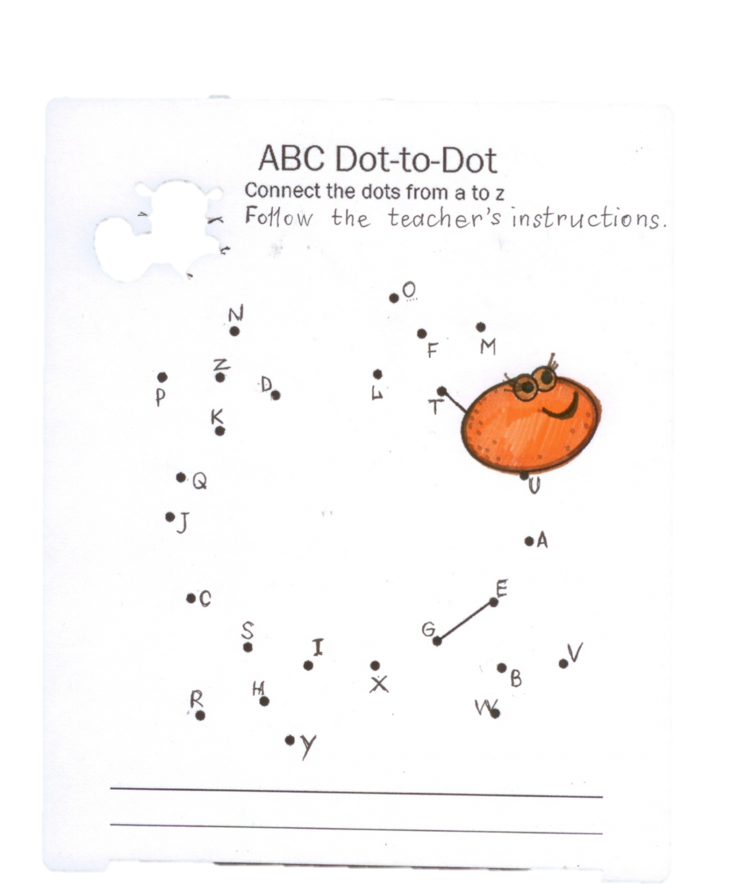
1. The teacher dictates the letters in the following order: U A E V B W G X I Y H R S C J Q K P Z N D L O F M T.
2. Then the teacher asks to connect the letters I and S, K and D, L and T.

Appendix 3

Picture dictation http://www.teachingenglish.org.uk/article/picture-dictation

Running dictation http://www.teachingenglish.org.uk/article/running-dictation
For example, a passage for running dictation
When one door of happiness closes, another opens; but often we look so long at the closed door that we do not see the one that has been opened for us. (Helen Keller)

Dictogloss http://www.onestopenglish.com/teenagers/skills/writing/teenagers-writing- dictogloss/146820.article
For example, I used the following text for dictogloss
CAT FACTS
Cats are one the most popular pets in the world. It is thought that there are more than 500 million domestic cats around the world. Cats and humans have had close relationships for thousands of years. Here are five fun facts about one of our favorite animals.
1. Do you often see cats sleeping? This is because cats save energy by sleeping 13 to 14 hours a day.
2. Cats have a very good sense of smell. A cat’s sense of smell is about 14 times stronger than ours.
3. Cats also have very good hearing. Cats can move their ears to face the place where they want to listen. 4. A male cat is called a tom, and a female cat is called a molly or a queen.
5. Cats have whiskers. You can tell how a cat is feeling by looking at its whiskers. If they are pointing forward, the cat is friendly. It they are flat on the cat’s face, they are being defensive

Shouting (silent) Dictation http://www.teach-this.com/ideas/dictations
For example, a passage for shouting dictation
A - An English teacher wrote these words on the whiteboard: "woman without her man is nothing".
B - The teacher then asked the students to punctuate the words correctly.
A - The men wrote: "Woman, without her man, is nothing."
B - The women wrote: "Woman! Without her, man is nothing."

Appendix 4

WHAT I LIKED BEST

WHAT I DIDN’T LIKE

References
- Mohammed R. Why dictation? , 2009, Available at: http://www.myenglishpages.com
- Lightfoot A. Using dictation, 2005, Available at: http://www.teachingenglish.org.uk
- http://www.teachingenglish.org.uk
- http://www.onestopenglish.com
- http://www.teach-this.com
- http://www.eslkidstuff.com
- http://www.makinglearningfun.com

