Загреба Ольга Николаевна,
учитель английского языка
Предмет: английский язык
Класс: 6 класс
Тема: “Australia” (Учебник Английский язык. VII класс: учеб. для общеобразоват. организаций и шк. с углубл. изучением англ. яз. / О.В.Афанасьева, И.В.Михеева. – 7-е изд. – М.: Просвещение, 2019.)
Тип урока: урок открытия «нового» знания
Цель урока: познакомить учащихся со страноведческим материалом из Интернета, которого нет в учебнике.
Образовательные цели:
- расширить и закрепить знания учащихся об Австралии
- научить слушать и понимать услышанное
Воспитательные:
- воспитывать умение работать фронтально
- прививать интерес к англоязычной стране
Тип урока: комбинированный
Формы контроля: фронтальный опрос
Планируемые результаты в соответствии с ФГОС:
Метапредметные УУД:
Коммуникативные: уметь участвовать в диалоге
Регулятивные: принимать и сохранять цели и задачи учебной деятельности, находить средства ее осуществления
Оборудование: проектор, доска, УМК «English», сайт https://videouroki.net.

Ход урока.
I.Warming up: Ввести в атмосферу иноязычной речи.
T: Hello everybody!
-Glad to see you. You are quite well, aren’t you?
-What places come to your mind when you see someone wearing ugg boots? Alaska? Norway? …No!
СЛАЙД 1
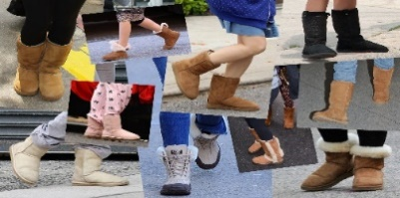
T: What country is associated with the word “selfie”?

СЛАЙД 2
-You think about the USA or China, don’t you? …My answer is No!
T: Well, I’ll give you the last chance… Jim Carrey. Where is he from?
СЛАЙД 3
T: If you have no idea, then follow the arrows on the map and you’ll find the way to this amazing country. (The teacher shows some pictures on the smart board…)
T: Pupils, have you guessed what country it is? Certainly you're right, it’s Australia. Here we are, in Australia … the only country in the world that covers an entire continent, but amazingly it’s also an island! An island continent, fancy that! Certainly the largest island in the world.
-The name Australia comes from Latin ‘terra australis incognita’ that means ‘unknown southern island’.
II. Основной этап: Автоматизировать лексику по теме: «Australia»

T: Pupils, look at the blackboard and repeat the following words after me. We will need these words at our lesson today.

Australia [ə 'streɪljə]
Tasmania [tæz 'meɪniə]
aborigines [æbə 'rɪdʒɪnz]
kangaroo [ ͵kæŋɡə 'ru:]
eucalyptus [ˌju:kə 'lɪptəs]
Southern Hemisphere [ 'sʌðə(r)n 'hɛmɪsfɪə]
the Commonwealth [ 'kɔmənwɛlθ]
Kookaburra [ 'kʊkə ,bʌrə]
Adelaide [ 'ædəleɪd]
monarch ['mɔnək]

СЛАЙД 4
T: Australia is also called “The land Down Under”, because of its geographical position. It lies in the Southern Hemisphere.
-Australian people call themselves Aussie.
-The total area of Australia is about 7.69 million square km. It is the world’s largest island – but the smallest continent.
СЛАЙД 5
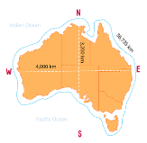
T: Lying between the Indian and Pacific oceans, the country is 4,000 km from east to west and 3,200 km from north to south, with a coastline 36,735 km long, making it the sixth-largest nation in the world.
СЛАЙД 6
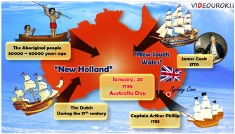
T: Australia's first people were the Aborigines who came from Asia to Australia more than 50,000 years ago.
The first Europeans on the Australian continent were the Dutch. They named the island continent "New Holland".
-In 1770, James Cook sailed along and mapped the east coast, which he named New South Wales.
-In 1783, the British Government set up a new penal colony in New South Wales.
-The flag raised at Sydney Cove, Port Jackson, on 26 January 1788, a date which became Australia's national day, Australia Day.
СЛАЙД 7
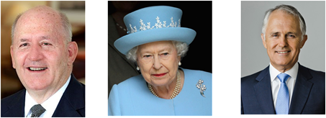
T: Until 1901 Australia was a British colony. Now Australia is an independent state within the Commonwealth headed by the British Queen Elizabeth II. The Queen is represented by Governor General - Sir Peter Cosgrove (since 2014). The Head of Government is Prime Minister – Malcolm Turnbull (since 2015).
СЛАЙД 8
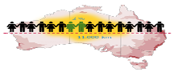
T: Australia's population is 24.6 million people. It is mainly of British origin. If you lined up the 24 million people who live in Australia, you would be able to cover approximately 11,000 km.
-Most of Australia's population lives on the fertile plains of the eastern and southeastern coasts.
СЛАЙД 9
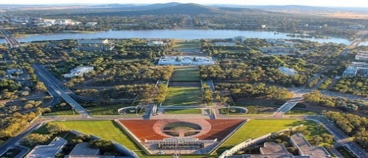
T: Canberra is the national capital and the centre of government.
-Canberra was chosen as the capital and that’s because Sydney and Melbourne couldn’t stop arguing about which one should be the capital. It is located in the Australian Capital Territory (ACT).
-Its name means “meeting place”, from the Aboriginal word ‘Kamberra’.
СЛАЙД 10
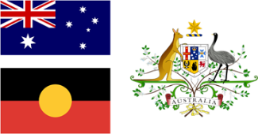
T: The Australian Flag is based on the Blue English. The British Union Jack is placed in the upper corner. This shows that Australia is part of the British Commonwealth. Beneath the Union Jack is a large white star with seven points. The points represent the six states and the territories. On the right hand side are the stars of the Southern Cross. It can always be seen in the Australian sky at night.
СЛАЙД 11
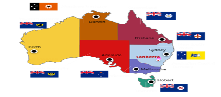
-Australia has six states and two major mainland territories.
T: The highest point of Australia is Mount Kosciusko (2,228 m).
-Have you heard of the Great Barrier Reef?
СЛАЙД 12
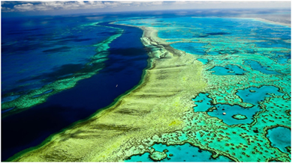
T: There are more than 1,500 species of fish and 400 types of coral in the Great Barrier Reef. No place on land has a greater variety of sea life!
СЛАЙД 13
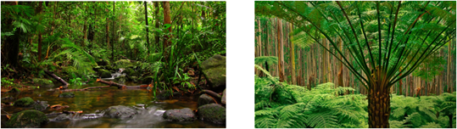
T: Australian forests are mostly made up of the eucalyptus trees.
-This is the Daintree Forest. It is one of the most diverse and beautiful examples of Mother Nature’s work in the world. Just look!
СЛАЙД 14
T: The most famous is probably a kangaroo.
-Everyone loves sleepy, grey koalas. After six months in a pouch baby koalas ride on their mother’s back. They eat the leaves of eucalyptus trees and drink almost nothing. The word koala means „no water“.
СЛАЙД 15
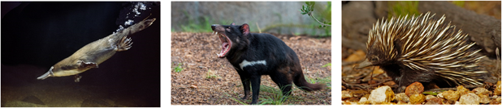
T: The platypus, echidna, and Tasmanian devil are also cannot be found anywhere in the world.
СЛАЙД 16
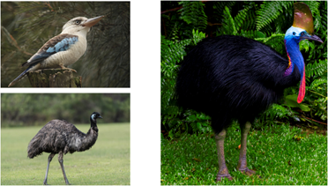
T: The most famous birds are the kookaburra, that sounds like someone laughing, the emu and the cassowary.
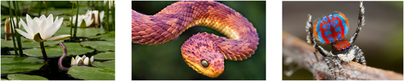
T: Australia is home to some of the deadliest animals on the planet. If you go there, be prepared! There are 36 species of poisonous spiders and 20 types of venomous snakes. There are only 25 venomous snakes in the world and Australia has 20 of them. Watch your step.
T: Be very attentive, please, because you will have to do some tasks and finish these sentences (https://videouroki.net/tests/136212617/):

- They called this land terra australis incognita, or ... . Australia is the world’s largest island and ... . 3. In the east the continent is washed ... . 4. There are three deserts there — ... . 5. In the north-east tropical forests ... . 6. New South Wales is ... . 7. Citrous fruits, grapes, peaches and ... . 8. Queensland has ... . 9. Most of the land in the South ... . 10. The state of Western Australia ... . 11. Tasmania, the island state, is sometimes called ... . 12. Darwin is its capital and ... . 13. The capital of Australia ... .In today's video we're going to discover another amazing country.

Write the names of the lands and water bodies which are around Australia

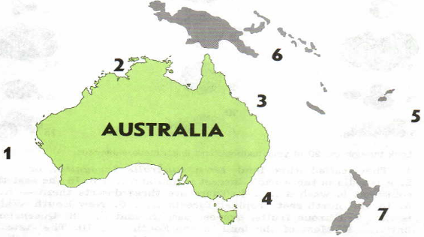
III. Заключительный этап (Reflection). Подведение итог уроку.
T: Open your diaries and write down the home task.
- So, boys and girls I’ll give you marks. I want to evaluate your activities.
P1 – you are the best, who works hard today. Your task is good and I put you excellent.
P2 – you want to work industries, but you have some mistakes. I put you good mark.
P3…;P4…;
T: Answer the question, please. Are we ready now to visit Australia?
- Do we know enough about Australia?
- What do we know?
T: It means that you have to do the quiz at home to continue our speaking about Australia. Open your pupil's mark book and write your homework. Your homework is…. Look at the board.
- Now our lesson is over. You can be free.
- Good bye!

