LEARNING TO LEARN
Чтобы достичь цели, надо, прежде всего, к ней идти!
CARD № 1
To achieve the aim of the lesson I’ll have to/I should… use…
look at… To fulfill the task I should/must… remember…
review…
be…
open…

CARD № 2
I want to receive a good mark today. That’s why I should
- be attentive, emotional, active;
- listen to my classmates, to my teacher;
- ask and answer different questions;
- participate in discussion;
- review some words and grammar rules;
- read a lot;
- open the book at page….
CARD № 3
Say what you have just done and how you’ve done it.
I (we) have just
- read an extract from the fairy-tale “…”;
- acted out the dialogue;
- practiced grammar;
- asked and answered different questions;
- played a game;
- written a test;
- retold the story…;
- reviewed the words.
CARD № 4

Finish the sentences:

We have reached the aim (achieved the goal) of the lesson.
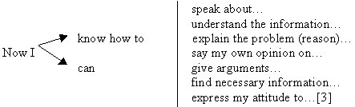
CARD № 5

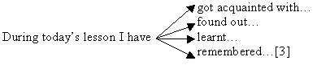
CARD № 6
What emotions do you feel? I feel
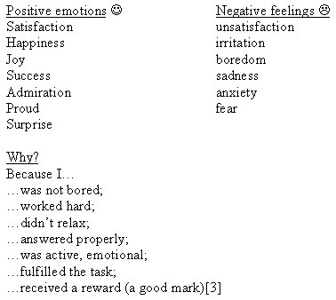

Choose the drawing that reflects your spirits:

CARD № 7
Why is reading useful?
Reading is useful because it helps us to:
- broad our mind;
- get knowledge;
- learn something new;
- develop and improve our speech;
- brush up our English…

