

REGULAR VERBS
Infinitive Simple Past
Walk walked
Receive received
Play played
Study studied
Stop stopped




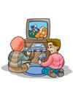


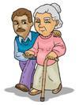
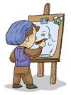

She ____________.
They ____________.
He ____________.
He ____________.
He ____________.
They ____________.
She ____________.
He ____________.
He ____________.
They ____________.
- What did these people do last night?
Complete the sentences with the past simple of the verbs.
B) Here are the things Ann wanted to do last weekend. She didn’t do all of them. Write what she did or didn’t do.
Example: I played football or I didn’t play football.
_____________________________________________
_____________________________________________
_____________________________________________
_____________________________________________
_____________________________________________
_____________________________________________
_____________________________________________
C) Write sentences about what you did or didn’t do last weekend.
Visit grandparents ✗
Play football ✓
Watch TV ✗
Study Maths ✓
Cook fish soup ✗
Help father ✓
Watch the birds ✓
Walk by the river. ✗
- She didn’t visit her grandparents.
- ___________________________
- ___________________________
- ___________________________
- ___________________________
- ___________________________
- ___________________________
- ___________________________

