Внеклассное мероприятие “What worlds of Wonder are our books”

The aim: to arouse the interest for reading English and American books

Tasks: development of communicative skills, communicative competence, skills of searching information, creativity, awareness of importance of learning English literature

Equipment: interactive board, computer, props

Leader: Good evening, boys and girls, ladies and gentlemen! We are very glad to see you at our unusual lesson. It is devoted to books. It’s a pity but people read books less and less. But
I’ m sure books will never disappear.

Leader:

Books

What worlds of wonder are our books!
As one opens them and looks.
New ideas and people rise
In our fancies and our eyes.
The room we sit in melts away.
And we find ourselves at play
With someone who, before the end.
May become our chosen friend.
Or we sail along the page
To some other land or age.
Here’s our body in the chair,
But our mind is over there.
Each book is a magic box
Which with a touch a child unlocks,
In between their outside covers
Books hold all things for their lovers.

Two boys are coming hugging each other.

Tom: Finn, where are we? I can’t believe my eyes.

Huck: I do understand nothing.

Tom: So do I.

Huck: Who are those boys and girls? They are wearing strange clothes. Let’s ask them.

Tom: Hey, who are you?

Pupil 1: We are the pupils. We study at school № 7. You are in Noyabrsk.

Huck: We don’t know such a town.

Pupil 2: But we know you very well. You are the heroes of the book “The adventures of Tom Sawyer and Huckleberry Finn”

Leader: We didn’t invite you to our party. You are very dirty. Have you ever washed yourselves? You see our boys and girls are tidy.

Tom: You remind me my aunt Polly. She always scolds me for being dirty.

Leader: I think she is right.

Tom: Maybe. But I hate washing myself, especially in the morning. We’d like to stay with you.

Leader: Boys, if you want to stay with us and take part in our party devoted to books, you should wash yourselves. (Tom and Huck wash themselves)

Leader: Great! Take your seats, please.

Boys: Thank you!

Leader: You were divided into three groups and given the tasks. I think you are ready with the tasks. But first of all, introduce your groups. The groups introduce themselves).
The first group is “Bookworms”
The second group is “Lovers of books”
The third group is “Connoisseurs of books”

Leader: I know you read books written by English and American authors. You should tell us about the author of the book and the book itself you liked best of all. Your retelling should interest other pupils and they’d like to read it.
Each group tells about the author of the book and the book itself and shows their presentation.

Leader: Look at the blackboard and guess the names of the heroes of famous books for children and give a brief characteristic of the heroes.
Picture № 1

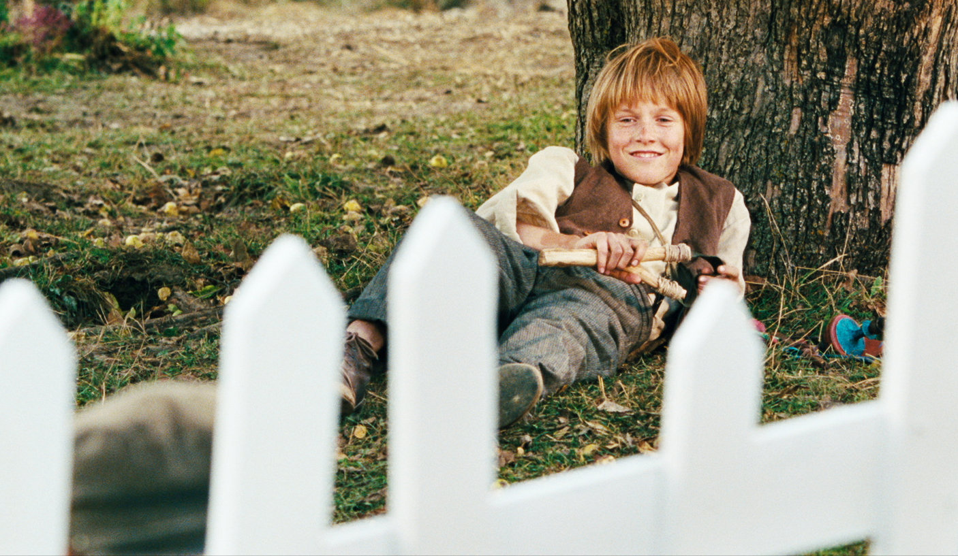

Who is this boy? Describe him!

Picture № 2

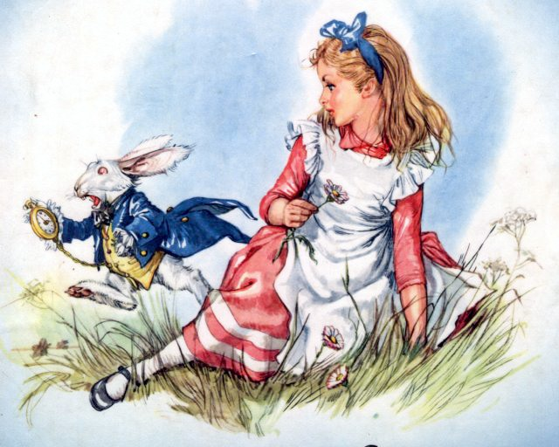

Picture № 3
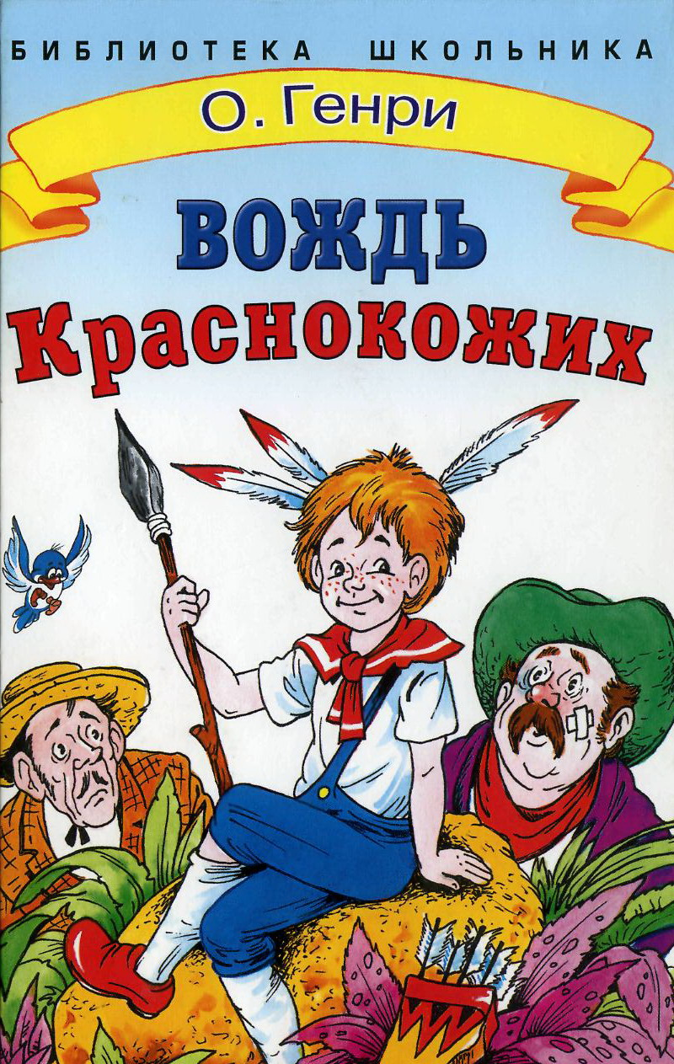
Leader: How clever you are! You know these heroes and it means you read them. Now you are to act out some episode from your favourite books.

The first group shows “A mad party” from the book “Alice in Wonderland” written by Lewis Carroll.
The first group shows an episode from the book “The Ransom of Red Chief” written by O. Henry.
The first group shows an episode from the book “Mary Poppins” written by Pamela Travers.

Leader: As far as I know people of different ages like to read fairytales. Now I’ll describe the fairytale and you will guess it.
- This story is about three brothers. They wanted to build their houses in the wood. But the wolf destroyed two of them. (The Little Pigs)
- This poor girl had no mother but she had a stepmother and two stepsisters. She was unhappy and worked a lot but at the end of the story the prince married her. (Cinderella)
- The girl wanted to visit her grandmother but she had a lot of problems on her way. The hunters helped to see her granny. (Little Red Riding Hood)
- This beautiful girl lived in water. She fell in love with the young man. She couldn’t live among people and was very unhappy. (Little Mermaid)
- The bear had a lot of friends. They lived in the forest and this fairytale is about their adventures. (Winnie-the-Pooh)
- This fish could do everything the old man and woman wanted her to do. But the old woman was greedy and selfish and finally they lost their property. (Golden Fish)

Leader: I want you to look at the blackboard. You can see some names of the books. Please tell us the authors’ names.
- “Gulliver’s Travels” – Jonathan Swift.
- “Alice in Wonderland” – Lewis Caroll.
- “The Prince and the Pauper”.
- “The Jungle Book” – Rudyard Kipling.
- “The Old Man and the Sea” – Ernest Hemingway.
- “Jane Eyre” – Charlotte Bronte
- “Hamlet” – William Shakespeare.
- “Ivanvoe” – Walter Scott.
- “David Copperfield” – Charles Dickens.
Leader: (announces the results, the winners get presents) I think you’ve enjoyed our party and learnt a lot. I hope you’ll find some free time to read books because they are our friends and help us in difficult situations. Thank you! Bye-bye!

