Достопримечательности Лондона
Сценарий мероприятия на английском языке для обучающихся 9-11 классов
В связи с всеобщей глобализацией и возрастающей роли английского языка на мировой арене, приобретением статуса международного языка общения в различных сферах человеческой деятельности, его практическая значимость очевидна.
На начальном этапе английский язык хотят учить все и берутся за это с большим энтузиазмом, а потом появляется скука и усталость. Скука на уроке – один из самых неприятных и трудно устранимых недостатков. Интерес к предмету падает, результаты обучения снижаются. Повышение познавательного интереса и стимулирование мотивации к изучению предмета – задача каждого педагога. Развитие креативных и творческих способностей учеников во время учебной и внеучебной деятельности многократно увеличивает эффективность образовательного процесса, создает условия для развития личности. Принимая это во внимание, необходимость проведения внеурочных мероприятий – это обязательное условие повышения мотивации к изучению иностранного языка.
Цели и задачи.
- Систематизация пройденного материала.
- Расширение знаний о столице Великобритании по сравнению с базовым уровнем.
- Развитие навыков диалогической речи.
- Совершенствование произносительных навыков.
- Развитие внимания и способности к узнаванию и сопоставлению нового и ранее изученного.
- Развитие умений и навыков, необходимых для решения задач творческого и поискового характера.
- Стимулирование обучающихся в изучении английского языка как средства знакомства с англоговорящими странами.
- Сплочение ученического коллектива.

My dream fulfilled
(сценарий мероприятия)
Ведущий: В одном северном городе России жил-был обычный ученик (Денис). И была у него мечта – мир посмотреть.
(Денис сидит в задумчивости, на экране – надпись: «I want to visit London, but how?..»)
Ведущий: И решил Денис денег заработать.
(1-я картинка: музыка, на экране – изображение улицы, а в это время ученик с табличкой или нашивкой «ЖКХ» подметает сцену; 2-я картинка: на экране – строящееся здание, а Денис в каске, с надписью «строитель» и кирпичом в руках идет по сцене; 3-я картинка: Денис раздает флаеры).
Ведущий: И вот настал долгожданный день.
(На сцене директор вручает Денису первую зарплату под звук фанфар).
Ведущий: Он договорился со своим другом по переписке и вылетел в Лондон первым же рейсом.
(На экране – самолет с надписью «Denis inside» и стрелочкой, затем на экране – карта и пунктиром обозначается перелет из Москвы в Лондон, звук приземляющегося самолета и приветствие прибывшим пассажирам. На сцене – встречающий с табличкой “Denis”.
Англичанин:Hello!
Денис: Hi!
Англичанин: Nice to meet you. How do you feel after a flight?
Денис: Thank you, I’m well.
Англичанин: I guess, you are tired and hungry. Let’s have a rest and then we’ll decide what to do, ok?
Денис: Ok!
(На экране: THREE HOURS LATER)
Англичанин: Would you like to see our famous sights?
Денис: Oh, yes, of course, I like active rest. What will we start with?
Англичанин: Let’s start with the Tower, all the more so it is so close, we have only to cross the Thames.
(на экране - картинка моста См. приложение 1, рис. 1)
Денис: By the way, do you know how old it is?
Англичанин: Oh, it was founded more than nine centuries ago. Initially, it was served as a fortress, a palace, a state prison and a royal treasury, now it’s a museum.
Денис: Photo me against it, please.
(Англичанин фотографирует Дениса на фоне Тауэра) См. приложение 1, рис. 2
Денис: Thank you, what's the next point of our trip?
Англичанин: I suggest you to look at St.Paul’s Cathedral, it is so beautiful and magnificent!
Денис: Sure, you rule. I have read, it is the third cathedral with this name, two others were burnt down. (на экране рисунок 3 приложение 1)
Англичанин: Yes, Christopher Wren, architect, was building it during all his life. (глядя на часы) Oh, we are pressed of time, yesterday I bought 2 tickets to the theatre. Let’s hurry up, we have to reach Covent Garden in a half an hour. (на экране рисунок 4 приложение 1)
Денис: What are our seats?
Англичанин: Row 6, seats 7, 8.
(сценка - См. приложение 2)
Денис: And now, what do we do?
Англичанин: What do you want? Actually I’m your guide, I’ll show you everything, you want.
Денис: What wheel is there?
Англичанин: Where?
Денис: Right there. (показывает пальцем) (на экране рисунок 5 приложение 1)
Англичанин: Don’t you know what it is? It’s our world known sight “London Eye”. We’ll see almost all London out of there.
Денис: Really? Let’s take a trip.
(Звучит голос экскурсовода - приложение 5, на экране демонстрируются картинки: Westminster Palace, Big Ben, Dali Museum, Trafalgar Square, Admiralty Arch, Whitehall, Westminster Abbey, Buckingham Palace, etc.) (на экране поочередно рисунки 6, 7, 8, 9, 10, 11, 12 приложение 1).
Денис: Wow! It was great, magnificent!
Девушка: Excuse me, I think, I went astray. We were with our Russian guide, I bought these beautiful postcards, but lost my group. Could you help me?
Денис: Yes, of course. Are you Russian? Where are you from?
Девушка: I’m from Tyumen. I guess you are Russian as well as me…
Денис: Да! Я из Ноябрьска.
Девушка: Слушай, неудобно как-то при твоем английском друге по-русски постоянно говорить.
Денис: Ты права, тем более надо подтягивать английский.
(обращаясь к англичанину) – Excuse me, Richard. I met my compatriot. Glad to introduce to you…
Девушка: Alice.
Англичанин: Nice to meet you.
Девушка: Nice to meet you too. So, what about finding my group?
Англичанин: I’m so sorry, but it’s unreal. At what time should you be at your hotel?
Девушка: By the evening meal, at 6 p.m.
Англичанин: I suggest you to join us, we’ll pass an entertaining time, and in the evening we’ll accompany you to the hotel.
Денис: Good idea!
Девушка: Okay, I agree. What are you going to do?
Денис: Oh… (пожимая плечами)
Англичанин: Let’s go to the Trafalgar Square.
Денис: And then?
Англичанин: Then? We’ll see.
(на экране - Trafalgar Square) (на экране рисунок 13 приложение 1)
Девушка: Oh , it is more beautiful than on photos.
(они слышат музыку)
Денис: Let’s listen!
(песня 1приложение 3)
(затем уже на выходе)
Денис: Look there! What’s going on?
Англичанин:In London there are many places where we can meet actors, dancers, bards, rope-dancers and clowns.
Девушка:Let’s have a look!
Англичанин:Why not?
(танец)
Денис: Cool!
Девушка:They are really talented!
Англичанин:Today we have seen many sights but we can’t finish this day without visiting one of parks of London. What about taking a bus and going to the Hyde Park?
Девушка: Of course, I’d like it very much.
(на экране картинка парка) (на экране рисунок 14 приложение 1)
Девушка: Oh, it’s really magnificent. It is so amazing to find a piece of green nature in the middle of a modern city.
Англичанин:I want to show you one place, Speakers’ Corner.
Денис: In my opinion, it’s rather interesting.
Англичанин: Decided, we’ll go there.
( стих приложение 4, песня приложение 3)
Девушка:It is so good to have a place where everyone can go and present their views, their poems, their speeches.
Англичанин: I see you are tired and sleepy, I propose you to interrupt our trip until tomorrow morning. Let’s meet at 9 o’clock near Tower Bridge on the left bank.
Девушка:Ok, see you tomorrow.
Денис: Bye, Alice!
Англичанин:Bye!
(на экране надпись «To be continued»)

Список литературы
- Сатинова В.Ф. Читаем и говорим о Британии и британцах.- 5-е изд. – Мн.:Выш. шк.,2000.- 255с.: ил.
- Хведченя Л.В. Английский для поступающих в вузы.- 19-е изд. – Мн.:Соврем. шк., 2006.- 463с.
- www. travel.ru
- http://planeta911.ru/scen.php
- http://infoenglish.info/publ/3-1
- http://salima-66.livejournal.com/78433.html
- http://festival.1september.ru/subjects/10/
- http://festival.1september.ru/articles/509140/
- http://festival.1september.ru/subjects/10/?n=79
- http://nenaidesh.ru/lib/Book-15-21.
- http://biblioverde.narod.ru/lang/engl/stihotvoreniya/english-poems_for_download.htmlhtml

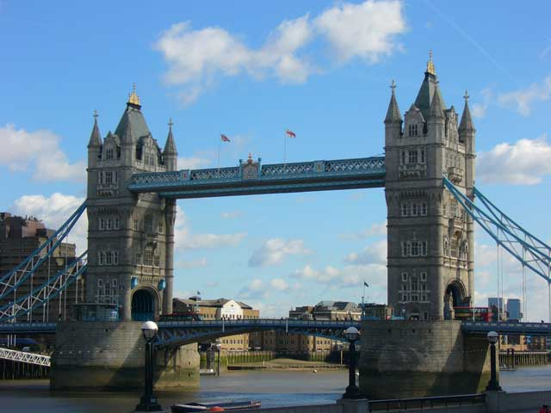
Приложение 1
рис. 1 Tower Bridge

рис. 2 Tower of London 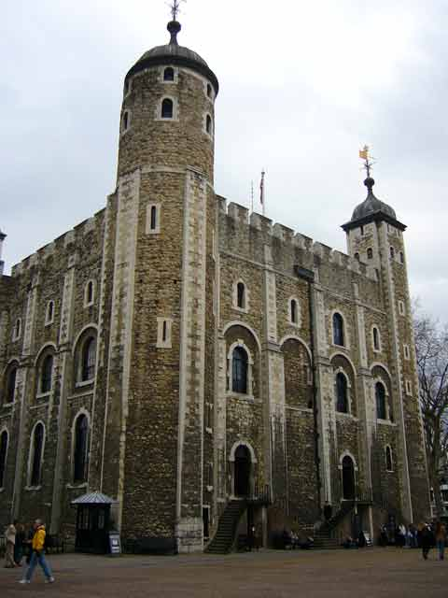
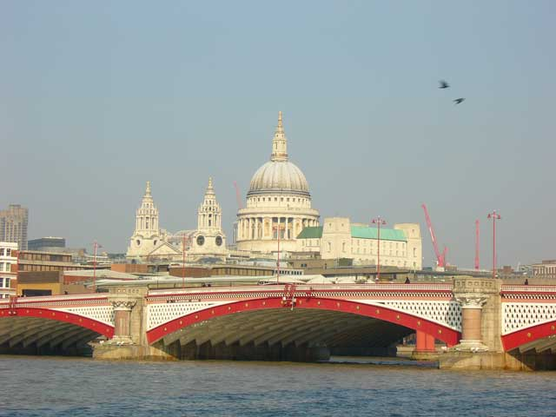 рис. 3 St. Paul’s Cathedral
рис. 4 Covent Garden 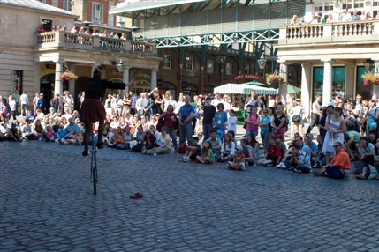

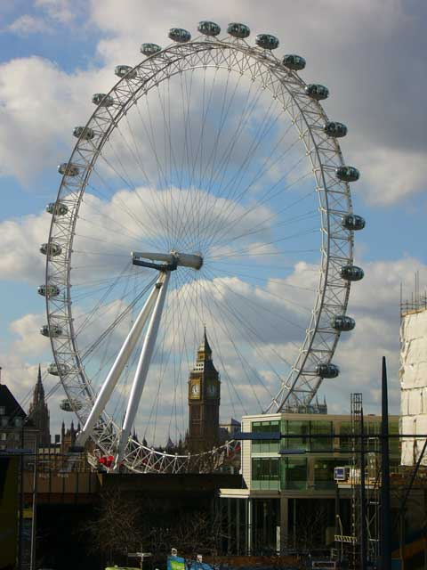 рис. 5 London Eye
рис. 6 Westminster Palace and Big Ben 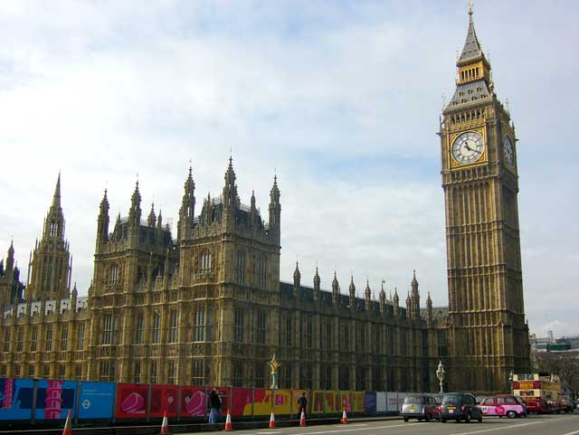
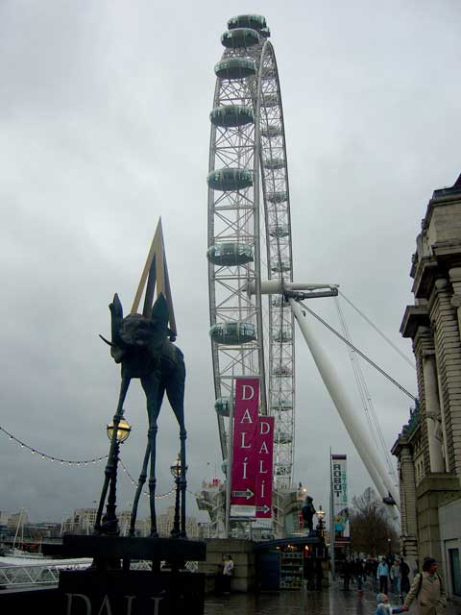 рис. 7 Dali Museum
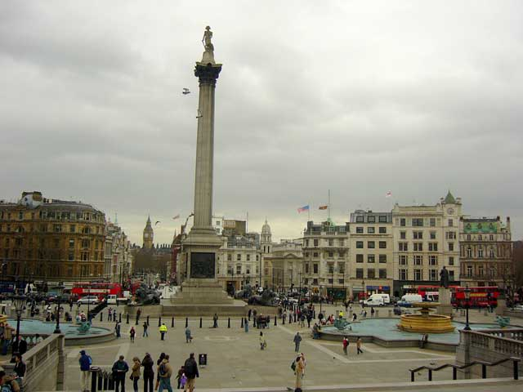 рис. 8 Trafalgar Square
рис. 9 Admiralty Arch 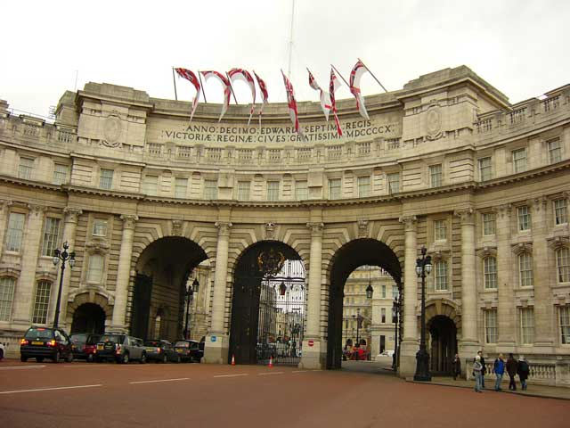

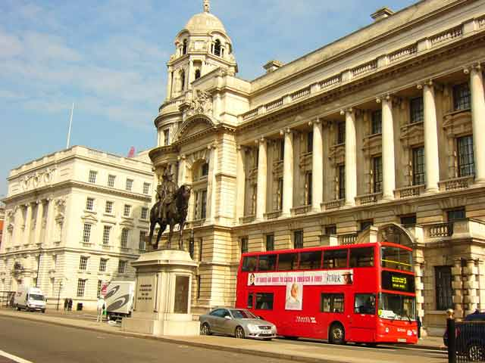 рис. 10 Whitehall

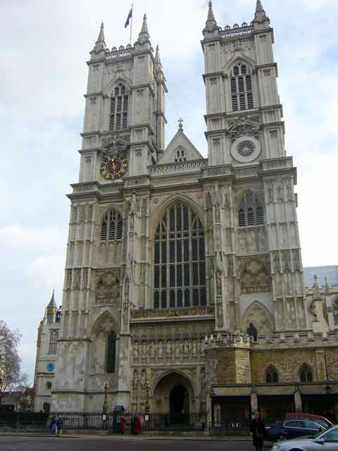

рис. 11 Westminster Abbey
рис. 12 Buckingham Palace 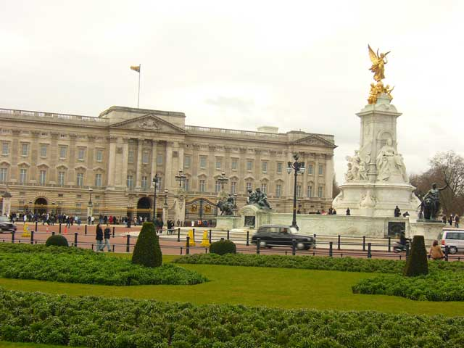

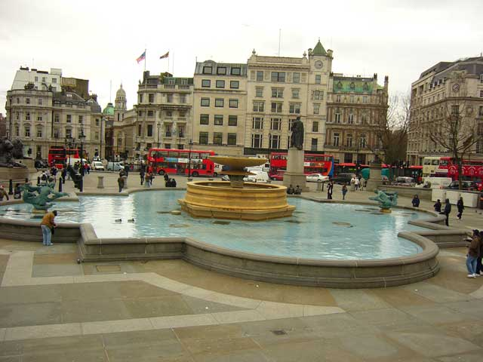 рис. 13 Trafalgar Square

Рис. 14 Hyde Park 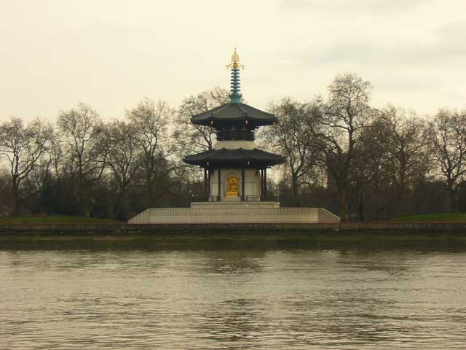

Приложение 2
« Romeo and Juliet»
(Act 2, Scene 2: Capulet`s orchard)
( Enter Romeo.)
Romeo: He jests at scars that never felt a wound.
( Juliet appears above at a window.)
But soft! What light through yoader window breaks?
It is the East, and Juliet is the sun!
Arise, fair sun, and kill the envious moon,
Who is already sick and pale with grief,
That thou her maid art far more fair than she,
Be not her maid, since she is envious,
Her vestal livery is but sick and green,
And none but fools do wear it. Cast it off.
It is my lady; O, it is my love:
O that she knew she were.
She speaks, yet she says nothing.
What of that?
Her eye discourses; I will answer it.
See how she leans her cheek upon her hand,
That I might touch that cheek.
Juliet: O, Romeo, Romeo! Wherefore art thou Romeo?
Deny thy father and refuse thy name;
Or, if thou will not, be but sworn my love
And I`ll no longer be a Capulet.
Romeo: Shall I hear more, or shall I speak at this?
Juliet: This but thy name that is my enemy.
Thou art thyself, though not a Montague!
What`s Montague? It is nor hand, nor foot,
Nor arm, nor face, nor any other part
Belonging to a man! O, be some other name!
What`s in a name? That which we call a rose
By any other name would smell as sweet.
So Romeo would, Were he not Romeo call`d,
Retain that dear perfection which he owes
Without that title. Romeo, doff thy name;
And for thy name, which is no part of thee,
Take all myself.
Romeo: I take thee at thy word.
Call me but love, and I`ll be new baptiz`d,
Henceforth I never will be Romeo.

Приложение 3
- Песня 1.

Let it be, let it be
When I find myself in times of trouble
Mother Mary comes to me,
Speaking words of wisdom,
Let it be.
And in my hour of darkness
She is standing right in front of me,
Speaking words of wisdom,
Let it be.

Let it be, let it be,
Let it be, let it be,
Whisper words of wisdom,
Let it be.

And when the broken hearted people
Leaving in the world agree,
There will be an answer,
Let it be.
For though they may be parted
There is still a chance that they will see,
There will be an answer,
Let it be.

Let it be, let it be,
Let it be, let it be,
There will be an answer
Let it be.

Let it be, let it be,
Let it be, let it be, 2 times
Whisper words of wisdom,
Let it be.

And when the night is cloudy there is still alright
That shines on me,
Shine until tomorrow,
Let it be.
A wake up to the sound of music
Mother Mary comes to me,
Speaking words of wisdom,
Let it be.

Let it be, let it be,
Let it be, let it be, 2 times
There will be an answer
Let it be.

Let it be, let it be,
Let it be, let it be,
Whisper words of wisdom,
Let it be ...

- Песня 2.

I just called
No new years's day
To celebrate
No chocolate covered candy hearts to give away
No first of spring
No song to sing
In fact here's just another ordinary day
No April rain
No flowers bloom
No wedding saturday within the month of June
But what it is
Is something true
Made up of these three words that I must say to you

I just called to say I love you
I just called to say how much I care
I just called to say I love you
And I mean it from the bottom of my heart

No summer's high
No warm July
No harvest moon to light one tender August night
No autumn breeze
No falling leaves
No even time for birds to fly to southern skies
No libra sun
No Halloween
No giving thanks to all the Christmas joy you bring
But what it is though
Oh so new
To fill your heart
Like no three words
That I ever knew

I just called to say I love you
I just called to say how much I care
I just called to say I love you
And I mean it from the bottom of my heart

I just called to say I love you
I just called to say how much I care
I just called to say I love you
And I mean it from the bottom of my heart.

Приложение 4
ANNABEL LEE
It was many and many a year ago,
In a kingdom by the sea,
That a maiden there lived whom you may know
By the name of Annabel Lee;
And this maiden she lived with no other thought
That to love and be loved by me.
She was a child and I was a child,
In this kingdom by the sea,
But we loved with a love that was more than love-
I and my Annabel Lee;
With a love that the winged seraphs of Heaven
Coveted her and me.
And this was the reason that, long ago,
In this kingdom by the sea,
A wind blew out of a cloud by night
Chilling my Annabel Lee;
So that her highborn kinsmen came
And bore her away from me,
To shut her up in a sepulchre
In this kingdom by the sea.
The angels, not half so happy in Heaven,
Went envying her and me: -
Yes!-that was the reason (as all men know,
In this kingdom by the sea)
That the wind came out of the cloud chilling
And killing my Annabel Lee.
But our love it was stronger by far than the love
Of those who were older than we-
Of many far wiser than we-
And neither the angels in Heaven above
Nor the demons down under the sea,
Can ever dissever my soul from the soul
Of the beautiful Annabel Lee:-
For the moon never beams without bringing me dreams
Of the beautiful Annabel Lee;
And the stars never rise but I see the bright eyes
Of the beautiful Annabel Lee;
And so, all the night-tide, I lie down by the side
Of my darling, my darling, my life and my bride,
In her sepulchre there by the sea
In her tomb by the side of the sea.
(bу Edgar Alan Poe)

Приложение 5
- Good afternoon! We are glad to see you on the board of our London Eye. We expect you’ll enjoy our excursion. Look to the right, on the other bank of the river you can see Westminster - central and important part of London. Most governmental buildings are situated there. On the left bank of the Thames is Westminster Palace, famous as the Houses of Parliament. It is the seat of the British Parliament. The Clock Tower with the hour-bell called "Big Ben" is known the world over.
The Houses of Parliament constitute perhaps the most popular and widely spread image of London, known and recognized throughout the whole world. In this famous palace are also many meeting halls and various parliamentary offices.
The Palace of Westminster, together with Victoria Tower and the Clock Tower — which houses the most famous clock in the world, Big Ben — form an unmistakable architectural complex. A light burns above Big Ben in the Clock Tower. This light at night and the flag during the day-time signal for the people of London that the members of Parliament, each from his own political point of view, are watching over the nation's interests.
The Houses of Parliament can be visited by the public. The entrance is through the door located at the foot of Victoria Tower and next to the Royal Arch. Visitors start at the Royal Gallery and then go to the House of Lords. Here there is the historical Woolsack, where the Lord Chancellor takes his place to preside over the sittings.
At the end of the House of Commons is the Speaker's Chair, on the right side of which the members of the parliamentary majority sit. The members of the groups that form the Opposition sit on the left, directly facing the Government benches.
Another interesting point in the Houses of Parliament is St. Stephen's Hall, which is decorated with very valuable frescos. From St. Stephen's Hall one reaches Westminster Hall. It is one of the oldest buildings in London.
We’d like to add some more information about Big Ben. What do you think - why is this bell called "Big Ben"? When the great bell was cast in London foundry in 1858, the question of its name was discussed in Parliament. One member said, "Why not call it Big Ben?"
There was much laughter among the members because the man in charge of public buildings was Sir Benjamin Hall, a very tall, stout man whose nickname was "Big Ben".
From that time the bell has been known as Big Ben. The bell is 7 foot 6 inches high, and 9 foot 6 inches across the mouth. It weighs 13.5 tons (about the same as two double-decker buses). "Big Ben" is the name of the bell only — not the clock, and not the tower.
A little bit below you can see the great glory of Westminster, the Abbey. Ancient tradition claims that St. Peter founded the first church here, but the Abbey's 900 years of existence since its dedication go back to Edward the Confessor. Henry III rebuilt the earlier church and the present building dates from his reign. If you have never visited the Abbey before, try to go in slowly and look about carefully. For the immediate effect, as you follow the wonderfully vaulted roof along the length of the nave, is a startling and breathtaking beauty. There is an element of greatness here that is not just concerned with size and height.
Dear tourists, can you see that column with a statue on it not far from the National Gallery?
This part of London is one of the nerve- centres of London. It was named Trafalgar Square to commemorate the historical naval victory won on the 21st of October 1805 by the British fleet under the command of Horatio Nelson over the combined French-Spanish fleet commanded by Villeneuve. The battle took place at Cape Trafalgar in the mouth of the Straits of Gibraltar and lasted several hours. Nelson was fatally wounded by a shot which broke his backbone. He died on board his flagship the Victory; but not before being told that he had won the battle.
Nelson's Column, with the statue of Admiral Lord Nelson on top, rises in the centre of Trafalgar Square. This most impressive monument is 170 feet (about 52 m) tall. The statue of Nelson itself, placed facing towards the sea he loved, measures 17 feet (more than 5 m) in height.
Quite often the square becomes the location for meetings and in it crowds of Londoners congregate to celebrate political rallies. So it can be said that Trafalgar Square is the heart from which the beat is emitted to all the Londoners.
There are many pigeons in the square and Londoners like to feed them. Everybody knows that the dove is the symbol of peace all over the world.
Close to the skyline, behind the Westminster Abbey you see one of London's most popular historical buildings. Buckingham Palace was built in 1703 for the Duke of Buckingham. Later restored by Nash, the present fagade was planned by Sir Aston Webb in 1913. At the west end of the Mall, Buckingham Palace is the London residence of the Sovereign. When the Queen is here, the royal standard flutters over the palace. The Royal Mews, in Buckingham Palace Road, house the coaches and horses used on all state occasions and are open to the public on Wednesday and Thursday. The Queen's Gallery, also in Buckingham Palace Road, has special exhibitions from the Royal collection and may be visited every day except Monday. In its entirety, the Palace and the beautiful gardens which surround it occupy an area of approximately 40 acres.
Altogether this is one of the most interesting places in London for the tourist.
The ceremony of the Changing of the Guard that takes place daily at eleven o'clock in the morning, constitutes one of the pageants that provokes most interest among tourists. Every day a large crowd of people gather to see this famous and traditional ceremony. It is an event that, in spite of its regularity, appears vested with that solemn classical ritual, of purely British flavour, that confers on the protocol surrounding the monarchy of the United Kingdom an appearance which is nobly aristocratic, and yet lively and popular at the same time. It is something typically and intimately part of London's character.
So, dear visitors, our little trip comes to its end. We hope to see you again on board.

